Experiment 9:Massive MIMO Capacity vs SNR and Gain Using MATLAB
Aim
To analyze the performance of a Massive MIMO system by studying channel capacity,
signal-to-noise ratio (SNR), and antenna gain using MATLAB.
Objectives
Objective – 1: Analyze Channel Capacity (bps/Hz)
Analyze the channel capacity of a Massive MIMO system for different signal-to-noise ratio (SNR)
values using MATLAB. Observe how channel capacity increases with improving signal quality
based on the Shannon capacity principle.
Objective – 2: Compare Signal-to-Noise Ratio (SNR) (dB)
Compare the signal-to-noise ratio for different communication scenarios using MATLAB.
Analyze the effect of SNR on the quality and reliability of wireless communication in Massive
MIMO systems.
Objective – 3: Analyze Antenna Gain (dB)
Analyze the antenna gain achieved by varying the number of antenna elements in a Massive
MIMO system using MATLAB. Observe how increasing the antenna array size improves
directional gain and enhances communication performance.
Software Required
• MATLAB
Theory
Massive MIMO employs a large number of antennas at the base station to simultaneously serve
multiple users. The increased spatial diversity and beamforming capability significantly improve
channel capacity, signal quality, and antenna gain. Channel capacity is influenced by the signal-
to-noise ratio (SNR), while antenna gain increases with the number of antenna elements. These
parameters are fundamental to achieving the high throughput and spectral efficiency required in
5G and beyond wireless communication systems.
Expected Outputs
Objective – 1 Plot of Channel Capacity (bps/Hz) versus SNR (dB).
MATLAB Code:
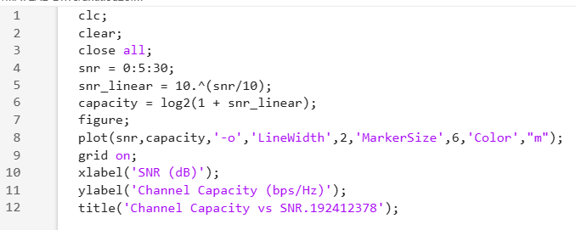
Expected Output
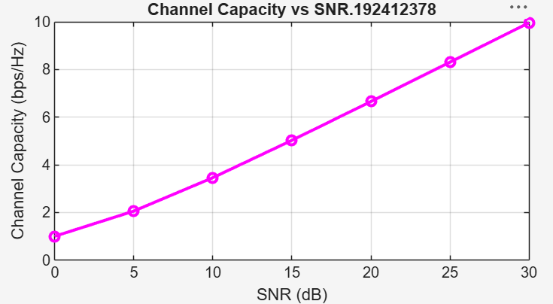
Objective – 2
Bar graph comparing SNR values under different communication scenarios.
Analyze the channel capacity of a Massive MIMO system for different signal-to-noise ratio (SNR)
values using MATLAB. Observe how channel capacity increases with improving signal quality
based on the Shannon capacity principle.
MATLAB Code:
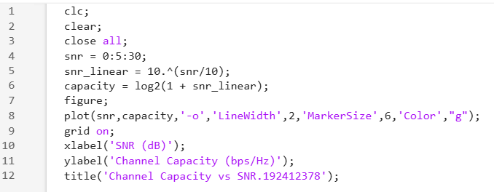
Expected Output
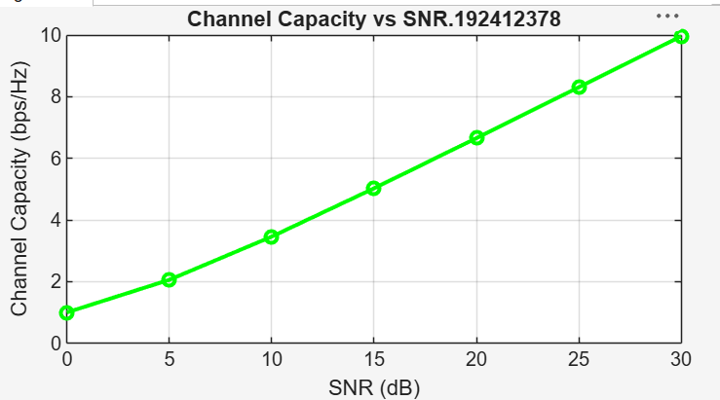

Objective – 3
Bar graph showing Antenna Gain for different antenna array sizes.

MATLAB Code:
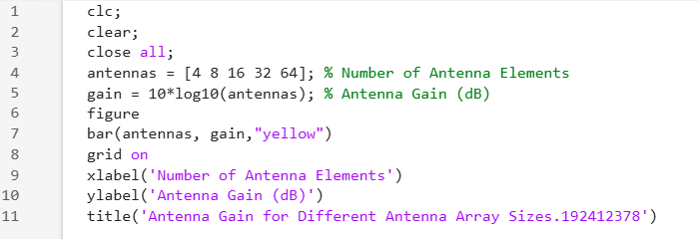
Expected Output
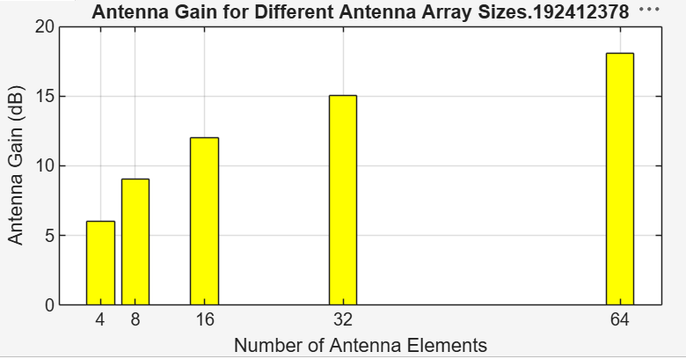

Result
The MATLAB analysis successfully demonstrated the relationship between channel capacity,
signal-to-noise ratio, and antenna gain in a Massive MIMO system. The results showed that higher
SNR and larger antenna arrays improve communication performance by increasing channel
capacity and directional gain.

